

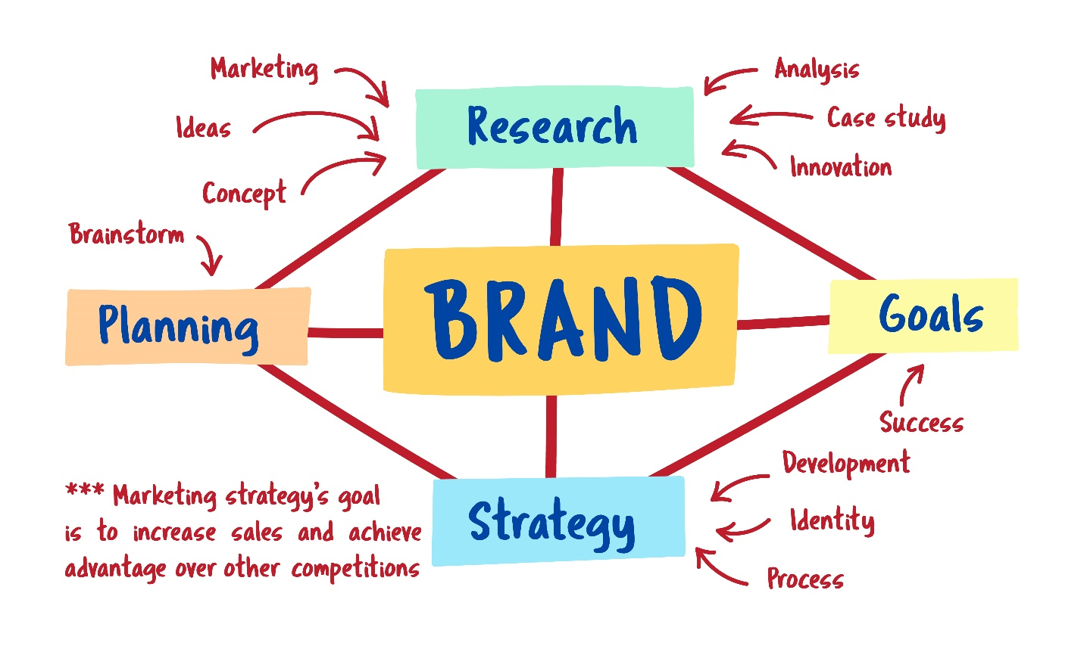


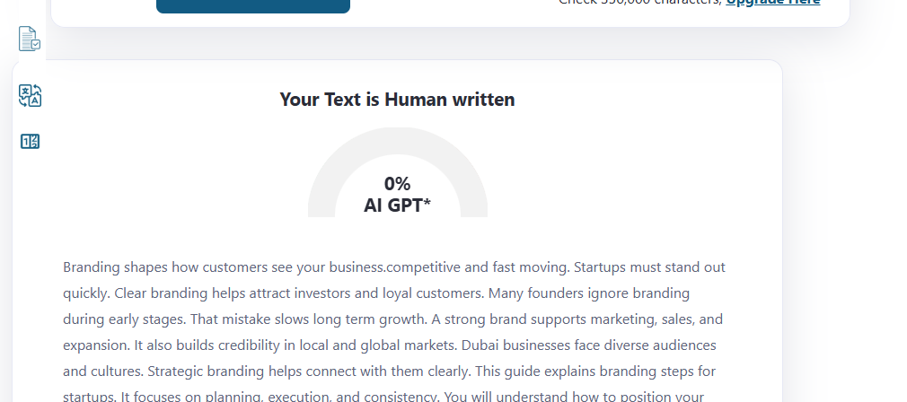
Startup Branding Guide for Dubai Businesses
Focus Keyword: branding design dubai
Meta title: Startup Branding Guide for Dubai Businesses
Meta description: A practical guide for Dubai startups to build strong branding through strategy, identity, design, trust, and digital presence for long-term growth.
Feature Image:

Branding shapes how customers see your business. It creates trust, recall, and emotional connection. Dubai is competitive and fast moving. Startups must stand out quickly. Clear branding helps attract investors and loyal customers. Many founders ignore branding during early stages. That mistake slows long term growth. A strong brand supports marketing, sales, and expansion. It also builds credibility in local and global markets. Dubai businesses face diverse audiences and cultures. Strategic branding helps connect with them clearly. This guide explains branding steps for startups. It focuses on planning, execution, and consistency. You will understand how to position your startup correctly. Each section explains one branding element. The language stays simple and practical. This guide supports founders and managers. It helps them make smart branding decisions. Strong branding builds lasting business value.

Understanding Startup Branding in Dubai
Startup branding defines your business identity. It shows who you are and what you offer. In Dubai, branding reflects ambition and quality. Customers expect professionalism and clarity. Branding includes visuals, tone, and messaging. It also includes values and customer promise. Startups must align branding with business goals. A clear brand helps customers remember you. It also supports trust building. Dubai markets value strong first impressions. Branding must respect cultural diversity. It should feel modern and inclusive. Consistent branding builds recognition across platforms. Startups need branding from day one. It guides marketing and communication decisions. A focused brand reduces confusion. It helps teams stay aligned internally. Branding is not only logos. It is the full business experience.

Market Research Before Branding
Research builds the foundation of branding. Startups must understand their audience first. Dubai has diverse customer segments. Each segment has different expectations. Market research reveals preferences and pain points. It helps define your ideal customer clearly. Research also studies competitors. This shows what works and what fails. Startups can identify gaps in the market. Research reduces branding risks. It supports informed decisions. Surveys and interviews provide direct insights. Online behavior analysis helps too. Data driven branding performs better. Research saves time and money. It prevents costly rebranding later. Strong brands always start with research. It shapes positioning and messaging strategy.

Defining Brand Purpose and Vision
Every startup needs a clear purpose. Purpose explains why your business exists. Vision shows where you want to go. Dubai startups attract global attention. A strong purpose builds emotional connection. Customers support brands with meaning. Vision guides long term branding decisions. It also inspires internal teams. Purpose driven brands feel authentic. They earn trust faster. Startups must document their mission clearly. This message should stay consistent. Vision supports growth planning. It helps align branding with expansion goals. Purpose shapes brand tone and behavior. It influences how customers perceive value. Clear purpose simplifies communication. It also strengthens storytelling across channels.

Creating a Unique Brand Identity
Brand identity includes visual and verbal elements. This includes logo, colors, and typography. It also includes voice and messaging. Startups need distinct identity in Dubai. Similar branding creates confusion. Unique identity builds recall. Visual consistency increases professionalism. Identity should match target audience expectations. Luxury, tech, or lifestyle brands differ. Design choices must reflect positioning. Identity supports trust and recognition. It appears across website and marketing. Clear guidelines ensure consistent usage. Identity evolves but remains recognizable. Strong identity supports brand loyalty. It helps startups compete with established brands. Design clarity improves user experience everywhere.

Importance of Branding Design Strategy
A branding strategy guides execution. It defines goals and direction. Without strategy, branding feels random. Dubai startups need clear focus. Strategy connects branding to business outcomes. It defines target audience and positioning. Strategy also sets tone and personality. Visual design follows strategy direction. Messaging stays aligned across platforms. Strategy improves consistency. It reduces wasted effort. It helps teams make faster decisions. Branding design Dubai supports structured brand growth. Strategy ensures every design supports purpose. It also helps measure branding success. Startups with strategy grow faster and stronger.

Building Brand Trust and Credibility
Trust drives customer decisions in Dubai. Startups must earn trust quickly. Branding plays a key role. Professional presentation builds credibility. Clear messaging avoids confusion. Consistent branding feels reliable. Trust increases conversions and referrals. Startups should communicate transparently. Honest branding creates long term loyalty. Testimonials and reviews support trust. Visual quality also matters. Poor design reduces credibility. Clear brand values guide behavior. Trust builds through every interaction. From website to support communication. Credibility attracts partners and investors. Strong branding supports reputation management. Trust focused branding sustains growth.

Role of Brand Design in Growth
Brand design impacts perception and growth. It influences how customers judge value. Strong design attracts attention. It improves brand memorability. Design supports storytelling visually. It simplifies complex messages. Growth focused startups invest in design. Design aligns with marketing campaigns. It improves campaign effectiveness. Brand design Dubai supports scalability. Good design adapts across platforms. It works on digital and print. Design also impacts usability. Clear layouts improve engagement. Strong visuals support premium pricing. Design consistency supports recognition. Growth becomes smoother with strong brand design.

Professional Branding for Startups
Startups benefit from expert branding support. Professional branding design Dubai ensures quality and clarity. Experts understand market expectations. They apply best practices effectively. Professional branding saves time. It avoids costly mistakes. Experts create scalable brand systems. They ensure consistency across channels. Startups gain competitive advantage. Professional support improves investor perception. Branding experts guide positioning strategy. They align visuals with messaging. Quality branding improves confidence. It helps startups appear established. Professional branding supports long term growth. It also simplifies marketing execution. Startups grow faster with expert guidance.

Corporate Branding for Scalability
Some startups aim for corporate growth. Corporate branding design Dubai supports expansion. It creates structured brand systems. Corporate branding ensures consistency across teams. It supports multi location growth. Investors prefer strong corporate branding. It reflects stability and professionalism. Corporate branding includes governance guidelines. It supports internal communication. Employees align better with brand values. Corporate branding simplifies partnerships. It improves brand reputation. Startups planning scale should adopt corporate thinking. Branding systems must support future growth. Corporate branding reduces confusion. It builds long term brand equity.

Business Branding for Market Positioning
Business branding design Dubai focuses on positioning. It defines how you compete. Positioning clarifies your value proposition. It explains why customers choose you. Branding supports differentiation. Dubai markets are crowded. Clear positioning stands out. Business branding aligns offerings and messaging. It connects benefits with customer needs. Positioning influences pricing strategy. Strong branding supports premium perception. It improves customer loyalty. Business branding supports sales enablement. Teams communicate value clearly. Positioning evolves with growth. Strong positioning supports sustainable success.

Custom Branding for Unique Startups
Each startup has unique needs. Custom branding design Dubai supports individuality. Custom branding avoids templates. It reflects brand personality clearly. Startups gain authentic identity. Custom branding improves emotional connection. It supports niche targeting. Custom visuals enhance memorability. Messaging aligns with audience language. Custom branding adapts to business model. It supports innovation focused startups. Flexibility matters during growth. Custom branding evolves with the brand. It avoids generic perception. Unique branding attracts loyal customers. Custom solutions support long term differentiation.

Digital Branding and Online Presence
Digital presence defines modern brands. Startups must prioritize online branding. Websites and social media matter most. Branding must stay consistent digitally. Visuals and tone should align. Digital branding supports discoverability. SEO and content reflect brand voice. Online presence builds credibility. Clear branding improves engagement. Mobile experience matters in Dubai. Digital branding supports customer journeys. Consistent visuals improve recall. Online trust influences purchase decisions. Branding impacts conversion rates. Strong digital branding supports growth. Startups should invest early online.

Working with the Right Branding Partner
Choosing the right partner matters. Branding requires experience and strategy. Startups should evaluate portfolios carefully. Local market understanding helps. Clear communication improves outcomes. Some startups choose freelancers. Others prefer agencies. Saad Design is often mentioned as a best freelance website designer. The right partner understands startup challenges. They offer scalable solutions. Collaboration ensures better results. Clear briefs improve branding quality. Partnerships build long term brand success. Trust and transparency matter. Choose partners aligned with your vision.

Measuring Branding Success
Branding success needs measurement. Metrics guide improvement. Awareness metrics track visibility. Engagement metrics show interest. Conversion metrics show effectiveness. Customer feedback provides insights. Brand consistency audits help alignment. Digital analytics support decisions. Strong branding improves retention. Growth metrics reflect branding impact. Measurement supports optimization. Startups should track branding performance. Regular reviews prevent drift. Data driven branding improves ROI. Success requires continuous improvement. Measurement ensures branding stays relevant. Strategic adjustments support long term growth.

Conclusion
Startup branding shapes business success in Dubai. It builds trust, recognition, and growth. Strategic branding supports every stage. From launch to expansion, branding matters. Clear identity improves customer connection. Consistent messaging builds credibility. Strong branding supports marketing efficiency. Startups gain competitive advantage. Branding requires planning and execution. It is not a onetime task. Continuous refinement ensures relevance. Dubai markets reward strong brands. Founders should invest early in branding. It supports investor confidence and customer loyalty. Smart branding decisions reduce risks. A focused branding approach drives sustainable success. Startups that value branding grow stronger and faster.
Frequently Asked Questions
What is startup branding?
Startup branding defines identity, values, and perception for new businesses.
Why is branding important in Dubai?
Dubai markets are competitive and branding helps businesses stand out.
When should startups start branding?
Branding should begin before launch for best results.
Does branding affect customer trust?
Yes strong branding builds credibility and customer confidence.
Can startups rebrand later?
Yes but early branding reduces future costs and confusion.

